NPS Analytics Report – FMEA Training Feedback Analysis

Introduction

Net Promoter Score (NPS) is a widely recognized metric used to evaluate participant satisfaction, training effectiveness, and the likelihood of recommending a training program to others. While an overall NPS score provides a high-level indication of participant sentiment, it does not explain the underlying factors influencing the score. Organizations require deeper analytical insights to understand which aspects of the training experience contribute to participant satisfaction and where improvements are needed.
This project presents a comprehensive analytics framework developed to analyze training feedback collected through NPS surveys. The framework performs automated data cleaning, feature engineering, exploratory data analysis, demographic analysis, batch-wise performance evaluation, statistical analysis, predictive modeling, and root cause analysis. The objective is to transform raw survey responses into actionable business insights that support data-driven decision-making and continuous improvement of training programs.

Problem Statement
Training feedback is often evaluated using only overall NPS values, which provides limited visibility into the factors affecting participant satisfaction. Manual analysis of survey responses is time-consuming, inconsistent, and does not effectively identify performance trends across batches, demographic groups, or training attributes. As a result, improvement opportunities may remain unnoticed, reducing the effectiveness of future training initiatives.
The organization requires an automated analytics solution capable of processing participant feedback, identifying key drivers influencing NPS, comparing training performance across different groups, predicting satisfaction outcomes, and generating business-ready reports to support continuous improvement and informed decision-making.

Project Objectives
The primary objectives of this project are:
- Develop an automated framework for processing and analyzing NPS survey data.
- Clean and standardize participant feedback for reliable analysis.
- Generate engineered features to enhance analytical capabilities.
- Perform exploratory and statistical analysis to identify trends and relationships within the data.
- Analyze participant feedback across batches, demographic groups, and training attributes.
- Identify the key factors influencing participant satisfaction through correlation and root cause analysis.
- Build and compare multiple predictive models to estimate participant NPS.
- Generate dashboard-ready datasets and business reports to support decision-making and continuous monitoring.

Dataset Description
The analysis was performed using participant feedback collected from training evaluation surveys conducted during the financial year 2025. Each record represents the response of an individual participant and includes demographic information, training evaluation scores, and qualitative feedback.
The dataset contains 161 participant responses with information covering demographic characteristics, learning experience, trainer effectiveness, overall satisfaction, and Net Promoter Score (NPS). Additional engineered features were created during preprocessing, including age and experience groups, composite quality indices, and NPS categories, to support advanced analytical and predictive modeling.
The major categories of information available in the dataset include:
- Participant Information
- Demographic Details
- Training Evaluation Scores
- Trainer Evaluation Scores
- Overall Satisfaction Ratings
- Net Promoter Score (NPS)
- Qualitative Feedback (Strengths and Improvement Suggestions)
- Engineered Features for Advanced Analytics

Methodology
The project follows a structured analytics pipeline to transform raw participant feedback into meaningful business insights. Each stage of the workflow performs a specific analytical task while preparing the data for subsequent analyses.
- Data Loading – Imported raw survey data and validated dataset integrity.
- Data Cleaning – Removed inconsistencies, standardized formats, and handled missing values.
- Feature Engineering – Created additional analytical features including age groups, experience groups, quality indices, and NPS categories.
- Exploratory Data Analysis (EDA) – Examined overall participant distribution and training performance patterns.
- Individual and Batch Analysis – Evaluated participant responses individually and compared training batches.
- Attribute Impact Analysis – Identified the relationship between training attributes and participant NPS.
- Demographic and Instructor Analysis – Assessed performance across demographic groups and trainer-related attributes.
- Text Analysis – Summarized participant strengths and improvement suggestions.
- Statistical Analysis – Performed descriptive statistics, correlation analysis, and hypothesis testing.
- Predictive Analysis – Trained and evaluated multiple machine learning models to predict participant NPS.
- Root Cause Analysis – Identified key improvement areas through gap analysis and priority ranking.
- Dashboard Integration – Generated automated datasets and reports for business dashboard visualization and ongoing monitoring.

Analysis & Key Findings
Data Cleaning
Objective
The first stage of the analysis focused on preparing the raw survey data for further processing. The objective was to ensure that the dataset was complete, consistent, and free from errors that could affect the reliability of the analytical results.
Analysis Performed
The participant feedback dataset was examined to identify missing values, duplicate records, inconsistent data formats, and incorrect data types. Text fields were standardized, unnecessary spaces and formatting inconsistencies were removed, and missing values in qualitative feedback columns were handled appropriately without affecting the integrity of the survey responses.
Data validation was also performed to ensure that numerical rating fields contained valid values and that categorical attributes such as gender, department, designation, and region were consistently represented throughout the dataset.
Key Results
The data cleaning process produced a structured and analysis-ready dataset with the following characteristics:
- Successfully processed 161 participant responses.
- Removed formatting inconsistencies across categorical attributes.
- Standardized text-based responses for uniform analysis.
- Validated numerical survey ratings for accuracy.
- Handled missing qualitative feedback without affecting quantitative analysis.
- Generated a clean dataset for feature engineering and subsequent analytical stages.
Business Impact
Data quality forms the foundation of reliable analytics. By cleaning and validating the dataset before analysis, the project ensures that all subsequent findings—including statistical analysis, predictive modeling, and root cause identification—are based on accurate and consistent information. This improves confidence in the insights used for training evaluation and business decision-making.
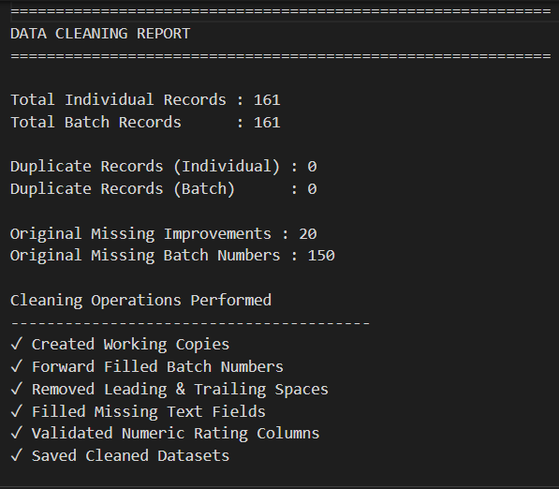

Feature Engineering
Objective
The objective of feature engineering was to enhance the analytical value of the dataset by creating new variables that better represent participant characteristics and training performance. These engineered features simplified complex survey responses into meaningful indicators, enabling more comprehensive statistical analysis, predictive modeling, and business reporting.
Analysis Performed
Several new features were derived from the cleaned dataset to improve the quality and depth of the analysis. Participant age and experience were converted into numerical values and grouped into meaningful categories to facilitate demographic comparisons. Composite indices were also created by combining related survey attributes, providing an overall measure of content quality, trainer effectiveness, and learning environment.
Additionally, participants were categorized based on their Net Promoter Score (NPS) into Promoters, Passives, and Detractors, allowing the project to evaluate participant satisfaction more effectively and support subsequent root cause analysis.
Engineered Features
The following features were created during this stage:
Feature | Description
Age (Years & Months) | Converted participant age into numerical values for analysis.
Experience (Years & Months) | Converted work experience into numerical values for comparison.
Age Group | Categorized participants into age-based groups.
Experience Group | Categorized participants based on professional experience.
Content Quality Index | Combined content-related survey attributes into a single performance indicator.
Trainer Effectiveness Index | Combined trainer-related attributes to evaluate overall trainer performance.
Learning Environment Index | Created an overall measure of the learning environment.
NPS Category | Classified participants as Promoters, Passives, or Detractors based on their NPS score.
Promoter Flag | Binary indicator identifying promoter responses.
Passive Flag | Binary indicator identifying passive responses.

Key Results
The feature engineering process significantly enhanced the analytical capabilities of the dataset by creating additional variables that represent participant demographics, training quality, and satisfaction levels.
These engineered features formed the foundation for multiple subsequent analyses, including demographic comparisons, correlation analysis, predictive modeling, and root cause identification. The creation of composite performance indices also simplified the interpretation of survey responses by consolidating related attributes into meaningful business metrics.
Business Impact
Feature engineering transformed raw survey responses into actionable performance indicators, enabling deeper insights into participant behavior and training effectiveness. The newly created indices provided a comprehensive view of content quality, trainer performance, and learning environment, allowing management to evaluate training outcomes more efficiently. Furthermore, the engineered variables improved the performance of predictive models and supported the identification of the key factors influencing participant satisfaction, making them valuable for future monitoring and decision-making.

Exploratory Data Analysis (EDA)
Objective
Exploratory Data Analysis (EDA) was performed to understand the overall distribution of participant responses, identify trends within the dataset, and establish a baseline for subsequent analyses.
Key Findings
- A total of 161 participant responses were analyzed.
- The overall average NPS was approximately 9.16, indicating a high level of participant satisfaction.
- The majority of respondents were classified as Promoters, reflecting a positive perception of the training program.
- Training evaluation scores remained consistently high across most learning and trainer-related attributes, indicating effective content delivery and participant engagement.
Business Interpretation
The overall survey results indicate that the training program was well received by participants. The high average NPS and strong promoter percentage suggest that the training successfully met participant expectations while maintaining consistent quality across multiple evaluation parameters. These findings establish a strong foundation for identifying opportunities for further enhancement.

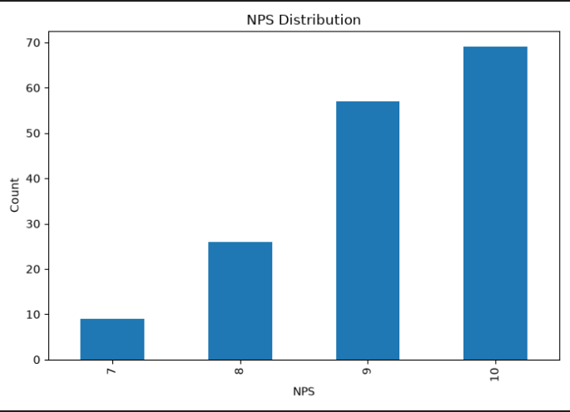

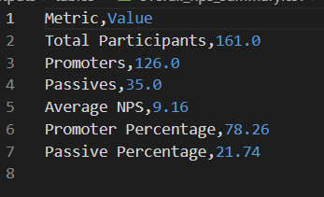

Individual Analysis
Objective
To evaluate participant responses individually and identify overall satisfaction levels across all survey respondents.
Key Findings
- Individual participant responses were analyzed based on NPS and training evaluation scores.
- Most participants provided high satisfaction ratings, with only a small proportion classified as Passives and no significant concentration of Detractors.
- The analysis confirmed consistently positive participant feedback throughout the dataset.
Business Interpretation
The results demonstrate that participant satisfaction remained consistently high across individual responses, indicating effective delivery of the training program and a positive overall learning experience.

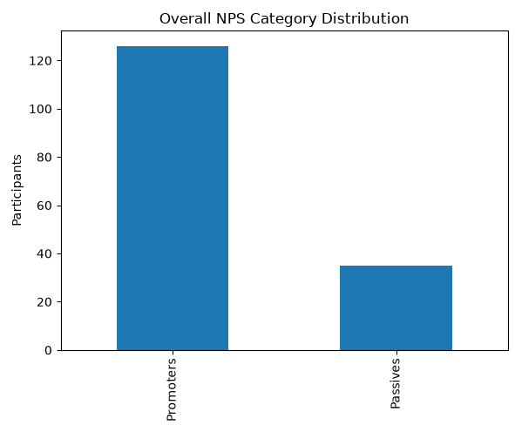

Batch Performance Analysis
Objective
To compare participant satisfaction across different training batches and identify performance variations.
Key Findings
- Batch performance remained consistently high across all training sessions.
- Batch-2 achieved the highest average NPS.
- Batch-8 recorded the lowest average NPS but still maintained positive participant feedback.
Business Interpretation
The findings highlight consistent training quality while identifying best-performing batches whose practices can be replicated across future programs.
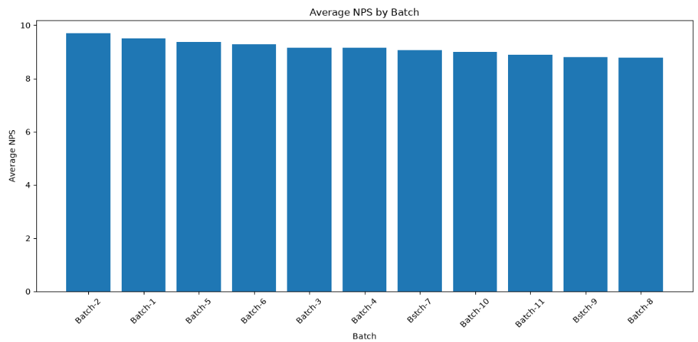
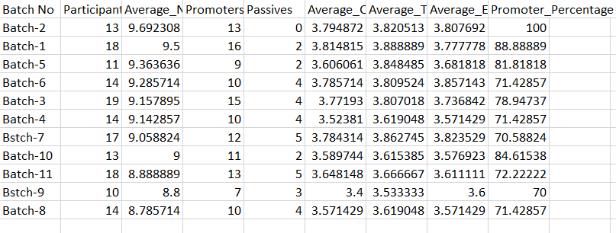

Attribute Impact Analysis
Objective
To identify the training attributes that have the greatest influence on participant satisfaction and NPS.
Key Findings
- Trainer Effectiveness Index and Content Quality Index showed the strongest relationship with participant NPS.
- Learning Environment also contributed positively, although with comparatively lower influence.
- These attributes were identified as the primary drivers of participant satisfaction.
Business Interpretation
Improving trainer effectiveness and training content quality is expected to have the greatest impact on increasing participant satisfaction and overall NPS.
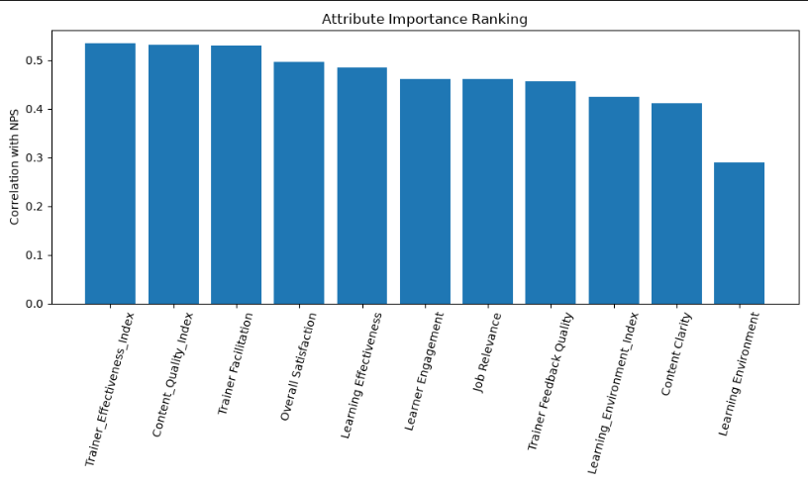
Demographic Analysis
Objective
To evaluate participant satisfaction across different demographic groups and identify variations in training experience.
Key Findings
- Participant satisfaction remained consistent across gender, age, department, region, role, and experience groups.
- Minor variations were observed; however, no demographic group demonstrated significantly lower satisfaction.
- The analysis indicates that the training program was effective across diverse participant categories.
Business Interpretation
The training program successfully catered to participants from different demographic backgrounds, demonstrating consistency and inclusiveness in learning outcomes.
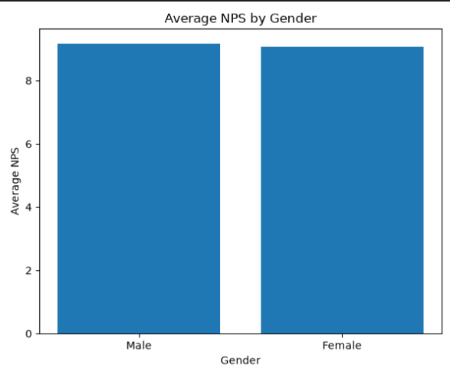
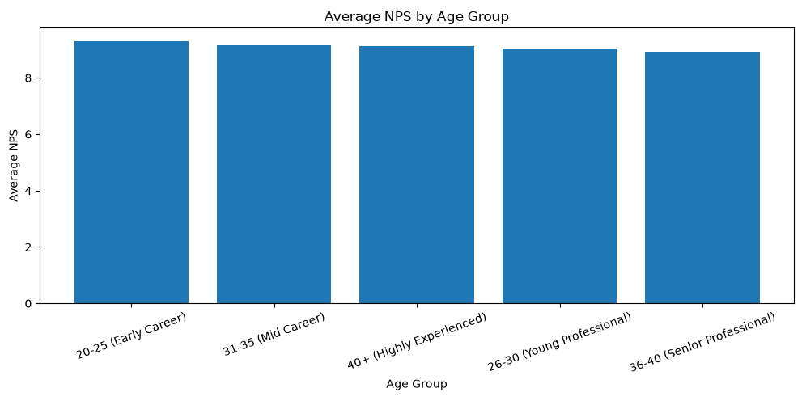

Instructor Performance Analysis
Objective
To assess trainer performance and identify key areas requiring improvement.
Key Findings
- Trainer Facilitation and Trainer Feedback Quality received consistently high participant ratings.
- Content Clarity was identified as the highest-priority improvement area.
- Overall trainer performance was rated positively by participants.
Business Interpretation
The analysis demonstrates strong trainer performance while highlighting opportunities to further enhance content delivery and learning effectiveness.
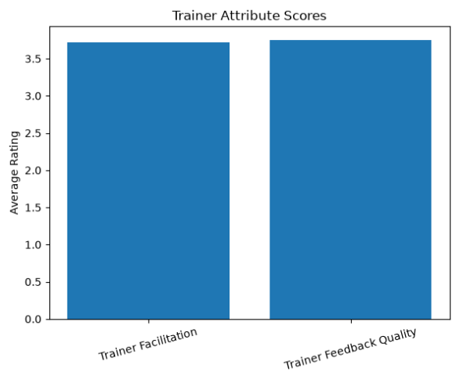
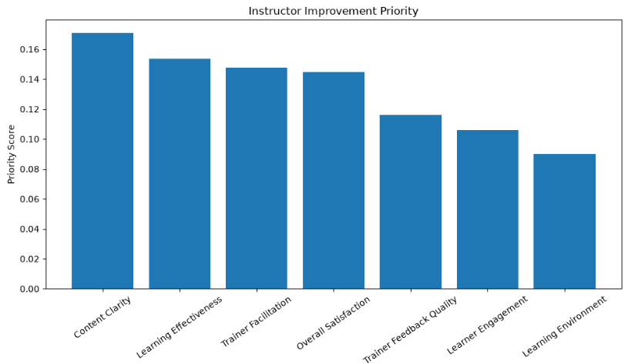

Participant Feedback Analysis (Text Analysis)
Objective
To summarize participant feedback and identify the most common strengths and improvement suggestions.
Key Findings
- Participants frequently appreciated trainer delivery, practical examples, and interactive sessions.
- Suggested improvements primarily focused on increasing practical demonstrations and providing additional learning materials.
- Overall qualitative feedback aligned with the high NPS scores.
Business Interpretation
Participant comments reinforce the quantitative findings and provide valuable insights for enhancing future training sessions.

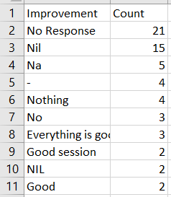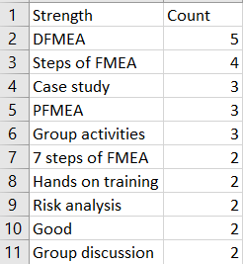

Statistical Analysis
Objective
To evaluate statistical relationships among training attributes and validate the factors influencing participant satisfaction.
Key Findings
- Positive correlations were observed between NPS and all major learning attributes.
- Trainer Effectiveness and Content Quality demonstrated the strongest statistical relationship with participant satisfaction.
- The correlation analysis confirmed the reliability of the identified performance drivers.
Business Interpretation
The statistical findings validate that improvements in trainer effectiveness and content quality are most likely to enhance participant satisfaction.
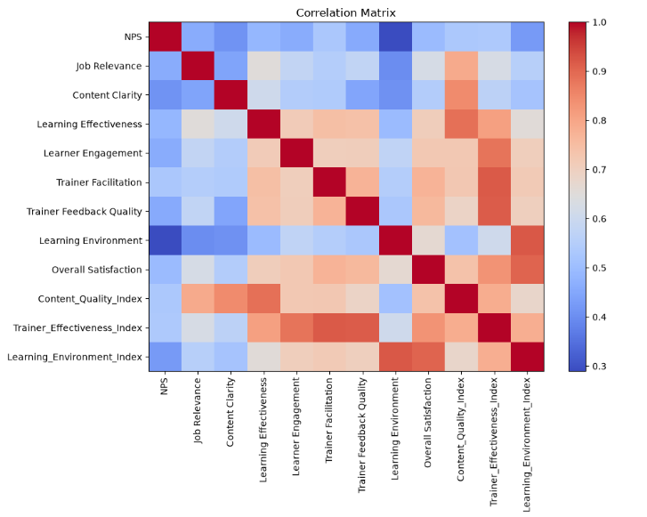
Predictive Analysis
Objective
To develop predictive models capable of estimating participant NPS and identifying the most influential training factors.
Key Findings
- Three machine learning models were trained and evaluated: Linear Regression, Decision Tree, and Random Forest.
- Linear Regression achieved the best overall performance on the available dataset.
- Trainer Effectiveness and Content Quality were identified as the most influential predictors of participant satisfaction.
Business Interpretation
Predictive modeling demonstrates that participant satisfaction can be estimated using training evaluation attributes, enabling proactive monitoring of future training effectiveness.
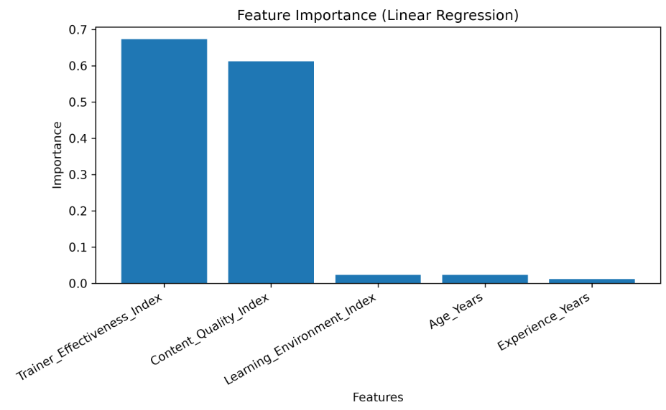
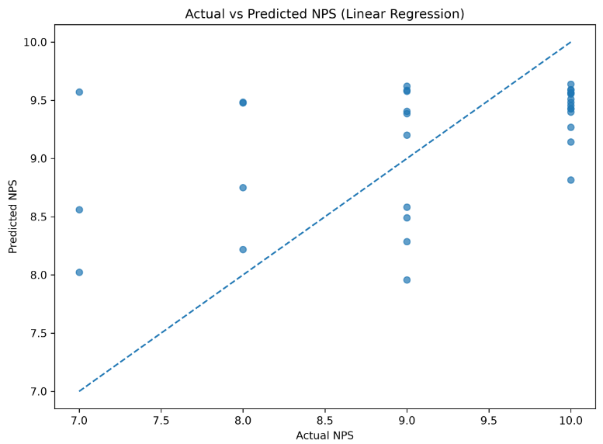

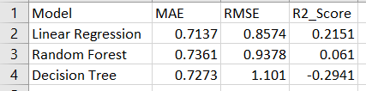
Training Performance Analysis & Key Insights
Objective
To identify the primary factors contributing to lower participant satisfaction and prioritize improvement initiatives.
Key Findings
- Content Clarity emerged as the highest-priority improvement area.
- Learning Effectiveness was identified as the second most influential improvement opportunity.
- Trainer Facilitation and Overall Satisfaction remained strong performance areas.
Business Interpretation
The analysis provides a clear improvement roadmap, enabling management to prioritize initiatives that are expected to produce the greatest increase in participant satisfaction and future NPS.

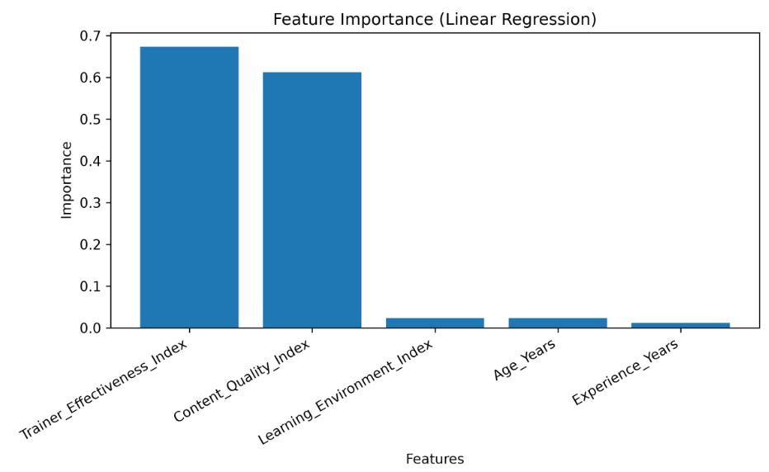

Conclusion

This project successfully developed an automated analytics framework for evaluating participant feedback collected through Net Promoter Score (NPS) surveys. By integrating data cleaning, feature engineering, exploratory analysis, demographic analysis, statistical evaluation, predictive modeling, and business reporting, the framework transformed raw survey responses into meaningful and actionable insights.
The analysis of 161 participant responses indicated a high level of overall participant satisfaction, with an average NPS of approximately 9.16 and nearly 78% of respondents classified as Promoters. The findings demonstrated consistent training performance across batches and demographic groups while identifying Trainer Effectiveness and Content Quality as the primary factors influencing participant satisfaction. The predictive analysis further validated these findings by confirming that improvements in these areas have the greatest potential to enhance future training outcomes.
Overall, the project provides a reliable and scalable analytics solution that enables data-driven evaluation of training programs, supports continuous improvement initiatives, and serves as a foundation for interactive dashboard reporting and future monitoring.

